The Impact Sexuality Priming with Varying Advertisement Methods has on Perceptions
- Student
Florida International University

Abstract
Methods One Students: Typically, authors add their abstract for the paper here on the second page. As you can see, the abstract for this paper is missing. Your job is to supply that abstract! Read over the following paper, which is an actual paper turned in by a former student taking Research Methods and Design II at FIU. This is similar to a paper you will write next semester. Review the studies in this paper, and spot the hypotheses, independent and dependent variables, participants, results, and implications, and write it up in one paragraph (no more than 250 words maximum). Make sure to include keywords as well (keywords are words or short phrases that researchers use when searching through online databases like PsycInfo – they need to be descriptive of the paper, so come up with three or four that seem to suit this paper). Good luck!
Keywords: methods, paper, abstract, assignment, preview

The Impact Sexuality Priming with Varying Advertisement Methods has on Perceptions
Sexual cues are often what drives people to form preconceptions of others characteristics and even their sexual intentions. These sexual cues can be found in social media platforms and sway people to think and perceive others in certain ways. For instance, priming sexual words can lead to people perceiving unknown social media users as being alluring, racy, and provocative, whereas priming romance words can lead to people perceiving unknown social media users as tender, sentimental, and kind (Dillman Carpentier, Parrott, & Northup, 2014). The aim for this study is to explore the influence priming sexuality with advertisements has on one’s perceptions of an unknown social media profile.
People are exposed to sexual stimuli daily, from sexually enriched commercial advertisements trying to sell a product to television programs talking about sexual content (Hundhammer & Mussweiler, 2012). According to Yi (1990), advertisements have the ability to use neutral information in tandem with priming stimuli to have an indirect persuasive effect on targets. The perceptions held by people exposed to the influence of priming stimuli are unconsciously formed as a result of a given stimulus. For example, to study the effect of subliminal sexual priming, Gillath and Collins (2016) ran five experiments that had participants partake in different neutral tasks while being exposed to either subliminal sexual primes or subliminal neutral primes. Compared to those exposed to subliminal neutral primes, those given subliminal sexual primes had increased positive affects after exposure (Gillath & Collins, 2016). Furthermore, Gillath and Collins (2016) found that those who experienced the increase in positive affects as a result of being exposed to subliminal sexual primes experienced more motivation to engage in the neutral task.
Sexual priming can influence people in a range of ways from motivating to even altering their perceptions and social behaviors. For example, Hundhammer and Mussweiler (2012) found that when given both pictorial and verbal sex stimuli, the self-views and non-sexual social behaviors of men and women were influenced by having increased gender self-stereotyping along with adapted gender stereotypical social behaviors. In another study looking at the influence of sexual priming, Dillman Carpentier (2017) found that when exposed to an online game embedded with primes of either sex, romance, or control, youth adults rated their sexual permissiveness as lower when exposed to the romance prime compared to the sex and control primes. That is, merely using romantic images as a prime within an online game, triggered thoughts of romance in the context of sexual activity leading to lower ratings of permissiveness (Dillman Carpentier, 2017).
In a similar light, Dillman Carpentier et al. (2014) sought to explore the effect of sexuality priming by testing the influence of priming the concepts of sex or romance on people’s perceptions of other social media users. Three experiments were run to see the influence of priming on three separate social media profiles including Facebook profiles, dating profiles, and LinkedIn profiles. This was tested by giving participants a word-search task either containing sexual, romantic, or control words, followed by having participants evaluate the sexual qualities and romantic qualities of the social media profiles, lastly participants rated their acceptance of the priming stimuli. It was found in all three experiments that cueing ideas related to sexual activity with sex primes lead to participants overestimating unknown social media users as having sexual characteristics and being more flirtatious, and provocative compared to participants that were not primed to think about sexual activity (Dillman Carpentier et al., 2014). In contrast, participants primed on romance judged unknown social media users as being more tender, sentimental, and kind compared to participants that were not primed (Dillman Carpentier et al., 2014).

Study One
Although past research has found evidence of sexual priming having influence over people’s motivation, behaviors, and perceptions, no study has looked specifically at the influence priming sexuality with advertisements has on one’s perceptions of unknown social media users. In this study, the notion that a sexualized advertisement and a romance advertisement can have an effect on forming perceptions of an unknown social media profile was analyzed. Participants were given the same fake Facebook profile with one of three advertisements, either sexualized advertisements, romance advertisements, or educational advertisements. There was two primary predictions. First, it was predicted that participants who saw sexualized advertisements accompanying the fake Facebook profile would view Riley the Facebook user in a more sexualized manner (i.e., more provocative) than participants who saw romance or educational advertisements. Second, it was predicted that participants who saw romance advertisements accompanying the fake Facebook profile would view Riley in a more romantic manner (i.e., more kind) than participants who saw sexualized or educational advertisements.
Methods Study One
Participants
This study was comprised of 132 students from Florida International University that were randomly selected to participate. Of these, 69 were male (52%) and 59 were female (45%), with 4 participants not providing their gender (3%). The ages of the sample ranged from 17 to 59 (M = 24.96, SD = 7.66). This included 26.5% Caucasian (n = 35), 40.9% Hispanic (n = 54), 1.5% Native American (n = 2), 17.4% African American (n = 23), 6.1% Asian (n = 8), and 7.6% of participants reporting “Other” (n = 10). See Appendix A.
Materials and Procedure
Potential participants were randomly selected and informed of the benefits and potential risks of participating in the study. The potential participants that consented to be in the study were randomly administered one of three questionnaires, which each consisted of six parts. In the first part, participants were instructed to look at a Facebook “About” page of someone named Riley Washington, which contained a generic profile picture of a sunset on the ocean and generic and neutral information about Riley. Each questionnaire depicted the same content, being that of a fake Facebook profile, with the only difference being the alternative conditions (sexuality prime, romance prime, or education prime) that ultimately led to different perceptions of the Facebook user Riley.
In the sexuality prime condition, participants read a small description at the top of the fake Facebook profile about a dating-oriented feature on Facebook that Mark Zuckerberg announced he wanted to add, bellow that participants were shown a Facebook profile “About” page with generic and neutral details about someone named Riley wanting to make friends, socialize, etc., along with three sexually suggestive advertisements at the bottom of the “About” page. The first advertised Axe body spray while displaying a shirtless man suggesting a shirtless woman. The second advertised alcohol by showing a woman in a sexually suggestive dress sharing a drink with a man whose face could not be seen. The third advertised perfume, showing a shirtless man wrapping his arms around a shirtless woman. In the romance prime condition, participants saw the same description of the dating-oriented feature, along with the profile “About” page of Riley with three advertisements at the bottom of the page with the only difference being these advertisements suggested romance. The first advertised the Sandals resort, showing a man and a woman having a romantic dinner. The second advertised perfume, showing a couple riding horses. The third advertised an online dating website called E-Harmony, showing a couple smiling. In the education priming condition, participants were exposed to all the same content with the only difference being the advertisements at the bottom of the page which were suggestive of education compared to the other conditions. The first advertised the University of Florida, the second one advertised Platt College, and the third advertised the ABC Academy. Two out of three advertisements in each condition had phrases at the bottom to follow a link for more information making it clear that they were electronic advertisements, giving the perception of authenticity. Further, the advertisements consistently had the same sizes across conditions ensuring the only difference between the advertisements was the content.
After participants finished reading the first page including the Facebook “About” page of Riley, they continued on to the remainder of the study. In the second part of the study, participants answered a series of ten questions rating their impression of Riley on an interval scale from one to six (1 = strongly disagree to 6 = strongly agree) without looking back at the first page. These questions asked whether they thought Riley seemed educated, flirtatious, sensitive, seductive, kind, tender, sentimental, provocative, outgoing, and sexy. In the third part of the study, participants moved on to rate how well each of ten terms described them on an interval scale from one to six (1 = strongly disagree to 6 = strongly agree). These terms included whether they described themselves as being assertive, sensitive, confident, emotional, businesslike, romantic, decisive, understanding, fearless, and warm-hearted. In the fourth part of the study, participants were asked for their demographic information, including gender, age, race/ethnicity, their first language, whether they are a Florida International University student, and their relationship status. Participants were informed they were free to leave blank any of the questions that would make them feel uncomfortable answering in this section. In the fifth part of the study, participants were asked whether they thought Riley was male, female, or unknown, seeing as Riley’s name had no gender traits. In the sixth part of the study, participants were asked to recall the general theme of the three advertisements they saw on the bottom of Riley’s Facebook profile without going back to look at the advertisements, they were given three themes to choose from (sexuality, romance, or education). Once participants finished all six parts to the study they were debriefed, as well as given insight on the purpose of the study and the main hypotheses.
Although there were several dependent variables, the primary focus was on participants perception of Riley, of whether they perceived Riley to be more provocative as well as if they perceived Riley to be more kind according to which prime condition they were in, and the manipulation check regarding what advertisements participants recalled seeing. It was hypothesized that participants who saw sexualized advertisements accompanying the fake Facebook profile would perceive Riley to be more provocative compared to those that saw either romantic or educational advertisements with the fake Facebook profile. It was also predicted that participants who saw romantic advertisements accompanying the fake Facebook profile would perceive Riley to be more kind compared to those that saw either sexualized or educational advertisements with the fake Facebook profile.
Results Study One
Using the advertisement prime theme condition (sexuality vs. romance vs. education) as the independent variable and the general advertisement theme participants recalled seeing as the dependent variable, a chi-square was ran which revealed a significant effect, X²(4) = 199.76, p < .001. Most participants in the sexuality prime condition recalled seeing sexual advertisements (90%). Most participants in the romance prime condition recalled seeing romance advertisements (87%). Finally, most participants in the education prime condition recalled seeing education advertisements (95.7%). These findings indicated that participants saw the original study outcome manipulation as intended. See Appendix B.
For the main analysis, a One-Way ANOVA which revealed a significant difference was ran with prime condition (sexuality vs. romance vs. education) as the independent variable and ratings of Riley’s provocativeness as the dependent variable, F(2, 129) = 10.04, p < .001. A Tukey post hoc test supported the hypothesis by showing that participants thought Riley was significantly more provocative in the sexuality prime condition (M = 3.60, SD = 1.24) than in both the romance prime condition (M = 2.98, SD = 0.61) and the education prime condition (M = 2.63, SD = 1.10). Participants in the romance and education prime conditions, however, did not differ from one another. These results supported the hypothesis by indicating that individuals are more likely to perceive an unknown Facebook user as being more provocative in the presence of sexualized advertisements compared to being in the presence of either romantic or educational advertisements. See Appendix C.
An analysis of participants perception of Riley being kind was also ran using a One-Way ANOVA revealing a significance, with prime condition as the independent variable (sexuality vs. romance vs. education) and ratings of Riley’s kindness as the dependent variable, F(2, 129) = 7.63, p < .001. A Tukey post hoc test showed that participants thought Riley was significantly more kind in the romance prime condition (M = 4.02, SD = 0.98) compared to the sexuality prime condition (M = 3.23, SD = 1.05). However, there was no significant difference between participants perceiving Riley as being more kind in the romance condition and education prime condition (M = 3.74, SD = 0.83). These results partially supported the hypothesis by showing that in the presence of romantic advertisements individuals are more likely to perceive an unknown Facebook user as being more kind than when in the presence of sexualized advertisements, but not more likely to perceive an unknown Facebook user as being more kind when shown romantic advertisements compared to educational advertisements. See Appendix D.

Discussion Study One
It was predicted that participants would perceive an unknown Facebook user named Riley as being more provocative when shown sexualized advertisements with the fake Facebook profile compared to when presented with the same Facebook profile and either the romantic or educational advertisements. Results supported this prediction, seeing as it was found that participants did perceive Riley to be more provocative in the sexual prime condition compared to the romance and education prime condition. It was as well predicted that participants would perceive Riley as being more kind when shown romantic advertisements with the fake Facebook profile compared to when presented with the same Facebook profile and either the sexualized or educational advertisements. Results partially supported this prediction, seeing as it was found that participants did perceive Riley as more kind in the romance condition compared to the sexual prime condition but not compared to the education condition. This could be because participants relate the perception of kindness to both romance and education, as such both condition primes of romance and education elicited the same perception of the unknown Facebook user equally. This begs the question: Could the method of advertisements such as print or commercial advertisements have a differentially effect on the strength of priming people to build perceptions of an unknown Facebook user? This is the focus of the second study.
Study Two
People come across advertisements every day whether it be while browsing social media and coming across print advertisements or watching commercial advertisements while browsing the web. Although perceptions are often formed after being exposed to priming stimuli, the method in which the priming stimuli is given may sway perceptions to be differentially stronger. For instance, elaborative processing of information in advertisements is diminished with a reduction of exposer time, leading to the diminishment of the messages the advertisement tries to rely on to people (Houston, Childers, & Heckler, 1987). Despite past studies looking at the differential effects advertisement methods have on priming effectiveness, no prior studies have examined the influence the method of advertisements with sexuality priming has on forming people’s perceptions of others. Therefore, the primary focus of this second study was to analyze the extent of effectiveness priming sexuality with differing methods of advertisements either print or commercial has on one’s perceptions of an unknown social media profile.
People are exposed to various advertisements on the daily, the intentions for exposing them all implore this goal of persuading people to adopt specific perceptions on what is being advertised (Meyers-Levy & Prashant, 1999). It has been seen how advertisements have the ability to use neutral information along with priming stimuli to have an indirect persuasive effect on targets (Yi, 1990). Both print and commercial advertisements emphasize their intended messages through visually oriented communications compared to other methods of advertisements such as radio advertisements (Houston et al., 1987). Specifically, commercial advertisements are often predominantly visual whereas print advertisements include extensive use of photographic and varying forms of illustrations (Schmitt, 1994).
To explore the differential effects online advertisement formats and persuasion knowledge has on audience reaction, Tutaj and van Reijmersdal (2012) conducted an experiment which showed that participants exposed to sponsored content advertisements found the content more informative as well as more amusing compared to banner advertisements that were seen to be irritating by participants. Further, they found that participants had a better understanding of advertiser’s intent with the online banner advertisement format compared to the integrated sponsored advertisements (Tutaj & van Reijmersdal, 2012). Intended advertisements that are directly given to people have a greater effect in informing as participants are more likely to engage with them to understand the message, compared to banner advertisements which are often perceived to be imposed on people and seemly intrusive (Tutaj & van Reijmersdal, 2012).
In the interest of exploring the time element of an advertisement on its processing effect of intended messages, a study by Houston et al. (1987) aimed to see whether an increase in exposer time to an advertisement would increase elaborative processing of the intended messages within an advertisement. Results showed that increased exposure time to an advertisement such as a commercial that exposes a message for a fixed amount of time increases superiority of memory effects of embedded messages compared to a print advertisement that can be overlooked in turn diminishing the effect of elaborative processing of the intended advertisement message (Houston et al., 1987).
As there is research to support this notion that advertisement methods differentially influence the ability to persuade people, this study aimed to closely look at this in tandem with the influence sexuality priming has on building perceptions. There has been support to show that sexuality priming can in fact influence impressions of others in a more sexual manner, for instance, Dillman Carpentier and colleagues (2014) found that when someone is exposed to sexually suggestive commercials the concepts of sexuality activated by the advertisement create related mental representations. These sexualized concepts exposed to them then alter their evaluation, in turn, forming impressions of an unknown person judged heavily on sexual characteristics (Dillman Carpentier et al., 2014).
In pursuance of the differential strength methods of advertisements have on leading people to form perceptions of others, study two analyzed the persuasive extent advertising methods such as commercial and print advertisements has on forming differential perceptions of an unknown social media user. First, it was predicted that participants who saw sexualized print advertisements accompanying a fake Facebook profile would view Riley the Facebook user in a more sexualized manner (i.e., more provocative) compared to participants who saw romance print advertisements. Second, it was predicted that participants who saw a sexualized commercial advertisement would view Riley in a more sexualized manner (i.e., more provocative) compared to participants who saw a romance commercial advertisement. Third, it was predicted that participants who saw a sexualized commercial and sexualized print advertisements accompanying a fake Facebook profile would view Riley in a more sexualized manner (i.e., more provocative) than participants who saw a romance commercial and romance print advertisements accompanying a fake Facebook profile. Last, it was predicted that participants who saw a sexualized commercial and romance print advertisements accompanying a fake Facebook profile would view Riley in a more sexualized manner (i.e., more provocative) than participants who saw a romance commercial and sexualized print advertisements accompanying a fake Facebook profile.
Method Study Two
Participants
This study was comprised of 180 students from Florida International University that were randomly selected to participate. Of these, 43 were male (39.8%) and 65 were female (60.2%). The age of the sample ranged from 15 to 40 (M = 22.59, SD = 3.99). This included 13% Caucasian/White (n = 14), 56.5% Hispanic Latino (n = 61), 1.9% American Indian/Alaskan Native (n = 2), 14.8% Middle Eastern (n = 16), 0.9% African American/Black (n = 1), 1.9% Caribbean (n = 2), and 11.1% of participants did not provide an answer (n = 12). See Appendix E.
Materials and Procedure
Prospective participants were randomly asked to part take in an online study being conducted for research purposes. If the participant verbally or otherwise agreed to partake in the survey they were then directed to take the survey through Qualtrics software. Participants were informed of the benefits and potential risks of participating in the study before starting the survey. Those that consented to be in the study were eligible to continue with the rest of the study, which consisted of six different parts.
In the first part of the study, the differential strength of advertisement methods was measured by presenting participants with a commercial advertisement in which they were instructed to take a few minutes to watch. The commercial had either a sexuality theme or a romance theme. Following this was the same Facebook “About” profile of Riley containing generic and neutral information used in study one along with the same print advertisements that were at the end of the profile page. These print advertisements had either a sexuality theme or a romance theme according to which conditions participants were placed in although the education theme advertisements used in study one was drop for this study. Participants were exposed to either the sexuality theme in both the commercial and the print advertisements, the romance theme in both the commercial and the print advertisements, the sexuality theme in the commercial and the romance theme in the print advertisements, or the romantic theme in the commercial and the sexuality theme in the print advertisements.
For the participants exposed to the sexuality commercial theme, a Trojan BareSkin Condoms commercial of thirty seconds in length was shown which depicted a sexual situation of a man and a woman about to engage in sexual activity. For the participants exposed to the romance commercial theme, a Kay Jewelers commercial of thirty-two seconds in length was shown which depicted a romantic situation where a couple is together and the man presents the woman with a necklace after saying he’ll away be there for her. The advertisements found at the end of the Facebook “About” profile of Riley were the same as the ones used in study one. For the sexuality theme advertisements participants were shown the same three advertisements at the bottom of the profile page featuring sexually suggestive themes and for the romance theme advertisements participants were shown the same three advertisements featuring romance suggestive themes.
After participants finished watching the commercial and reading the Facebook “About” page of Riley with the advertisements, they continued on to the remainder of the study. Similar to study one, the second part presented participants with a series of questions rating their impression of Riley on an interval scale from one to six (1 = strongly disagree to 6 = strongly agree). Unlike study one instead of presenting a series of 10 questions, this study presented participants with a series of thirteen questions asking whether they thought Riley seemed educated, flirtatious, sensitive, seductive, kind, tender, sentimental, provocative, outgoing, sexy, promiscuous, gentle, and committed. Similar to study one, the third part of the study included having participants rate how well each of ten terms described them on an interval scale from one to six (1 = strongly disagree to 6 = strongly agree), including terms rating whether they described themselves as being assertive, sensitive, confident, emotional, businesslike, romantic, decisive, understanding, fearless, and warm-hearted. In the fourth part of the study, participants answered two manipulation check questions which asked what was the general theme of the three advertisements they saw at the bottom of the Facebook page, in which they were given two themes to chose from (sexuality or romance). The other question asked what they saw first in the first part of the survey, in which they had two options to chose from (Riley’s profile or the commercial). In the fifth part of the study, participants were aked for their demographic information, including gender, age, and ethnicity. In the sixth part of the study, participants were asked to recall whether they thought Riley was either male, female, or unknown. Once participants finished all the parts to the online survey they were debriefed about the study and given insight on the main hypotheses.
Although there was several dependent variables, the primary focus involved participants perceptions of Riley, of whether they perceived Riley to be more provocative as well as if they perceived Riley to be more kind according to which conditions they were in. The interaction between advertisement theme and commercial theme was also analyzed for both dependent variables.
Results Study Two
Using the advertisement theme condition (sexual vs. romance) as the independent variable and the general advertisement theme participants recalled seeing as the dependent variable, a chi-square was ran which revealed a significant effect X²(1) = 78.25, p < .001. Most participants in the sexuality theme condition recalled seeing advertisements with a sexual theme (94.8%). Most participants in the romance theme condition recalled seeing advertisements with a romance theme (90%).These findings indicate that participants saw the advertisements theme manipulation as intended. See Appendix F.
To test the first dependent variable, a 2 X 2 factorial ANOVA wan ran with advertisement theme (sexuality vs. romance) and commercial theme (sexuality vs. romance) as the independent variables and ratings of Riley’s provocativeness as the dependent variable. Results showed a significant main effect for advertisement theme on ratings of Riley being provocative, F(1,104) = 6.76, p = .011. Participants in the sexuality condition (M = 4.29, SD = 1.34) perceived Riley as being more provocative than participants in the romance condition (M = 3.62, SD = 1.37). There was, however, no significant main effect for commercial theme on ratings of Riley being provocative, F(1,104) = 1.74, p = .189. This means there was no significant difference in ratings of Riley being provocative with commercial theme between the sexuality condition (M = 4.15, SD = 1.39) and the romance condition (M = 3.81, SD = 1.37). Unfortunately, there was no interaction of advertisement theme and commercial theme, F(1,104) = .017, p = .896, meaning that the ratings of Riley being provocative did not significantly differ among sexuality advertisement theme with sexuality commercial theme participants (M = 4.48, SD = 1.27), sexuality advertisement theme with romance commercial theme participants (M = 4.10, SD = 1.40), romance advertisement theme with sexuality commercial theme participants (M = 3.77, SD = 1.45), and romance advertisement theme with romance commercial theme participants (M = 3.46, SD = 1.30). See Appendix G.
To test the second dependent variable, another 2 X 2 factorial ANOVA was ran with advertisement theme (sexuality vs. romance) and commercial theme (sexuality vs. romance) as the independent variables and ratings of Riley’s kindness as the dependent variable. There was no significant main effect for advertisement theme on ratings of Riley being kind, F(1,104) = .580, p = .448. This means there was no significant difference in ratings of Riley being kind with advertisement theme between the sexuality condition (M = 5.10, SD = 0.77) and the romance condition (M = 4.98, SD = 1.02). Similarly, there was no significant main effect for commercial theme on ratings of Riley being kind, F(1,104) = 2.75, p = .100. This means there was no significant difference in ratings of Riley being kind with commercial theme between the sexuality condition (M = 5.18, SD = 0.72) and the romance condition (M = 4.91, SD = 1.02). Unfortunately, there was no interaction of advertisement theme and commercial theme, F(1,104) = .205, p = .652, meaning that the ratings of Riley being kind did not significantly differ among sexuality advertisement theme with sexuality commercial theme participants (M = 5.21, SD = 0.68), sexuality advertisement theme with romance commercial theme participants (M = 5.00, SD = 0.85), romance advertisement theme with sexuality commercial theme participants (M = 5.15, SD = 0.79), and romance advertisement theme with romance commercial theme participants (M = 4.79, SD = 1.22). See Appendix H.

Discussion Study Two
Although study two hypothesized that advertisement theme and commercial theme would impact participants perceptions of Riley, results partially supported this. For the dependent variable ratings of Riley’s provocativeness, results showed that advertisement theme effected ratings of Riley being more provocative when the theme was sexual compared to when the theme was romantic which confirmed prediction. Despite predictions to the contrary, results showed that commercial theme did not effect ratings of Riley being more provocative as those given a commercial with a sexualized theme rated Riley similarly as being more provocative as those given a commercial with a romantic theme. Nor was there an interaction between advertisement theme and commercial theme despite our prediction that those given advertisements and commercials with a sexual theme would rate Riley as being more provocative.
Moreover, for the dependent variable ratings of Riley’s kindness there was no main effects for both advertisement theme and commercial theme, nor was there an interaction. That is, advertisement theme did not affect participants ratings of Riley’s kindness as those given advertisements with sexual themes and those given advertisements with romantic themes had similar ratings of Riley’s kindness despite predictions that posited those given advertisements with a romantic theme would rate Riley as being more kind compared to those given advertisements with a sexual theme. Commercial theme as well did not have an effect on ratings of Riley’s kindness as those given a commercial with a sexual theme and those given a commercial with a romantic theme had similar ratings of Riley’s kindness despite predictions that said those given a commercial with a romantic theme would rate Riley as being more kind than those given a commercial with a sexual theme. Nor was there an interaction between advertisement theme and commercial theme despite our prediction that those given both advertisements and a commercial with a romantic theme would rate Riley as being more kind.
General Discussion
In assessing the effect of priming on perceptions of an unknown social media user, it was predicted that participants exposed to sexually primed print advertisements would perceive an unknown social media user as being more sexual (i.e., provocative) than those exposed to romance primed print advertisements. This hypothesis was supported in both study one and two. In both studies the data collected showed a significant effect of sexuality priming with print advertisements on participants perceptions of an unknown social media user being more sexual. These findings reinforce the findings of Dillman Carpentier et al. (2014) that sexual priming can lead to overestimates of sexual characteristics in unknown social media users. It was as well predicted that participants exposed to romance primed print advertisements would perceive the unknown social media user as more romantic (i.e., more kind). This hypothesis was not supported in study two and only partially supported in study one as results found that participants exposed to romance primed print advertisements perceived the unknown social media user as being more romantic compared to those exposed to sexual print advertisements but not when compared to the control education primed print advertisements. Such findings suggest that those that promote themselves on social media may not have control over the perceptions being made about them as sexually primed print advertisements appearing in tandem with their social media profile may sway the perceptions others make about them.
Regarding testing the effect priming the perceptions of an unknown social media user through a different method of advertisement, it was predicted that participants exposed to a sexually primed commercial advertisement would perceive the unknown social media user as being more sexual (i.e., provocative) than those exposed to a romance primed commercial advertisement. This hypothesis was not supported in study two as results showed that a sexually primed commercial advertisement did not influence participants perception of the unknown social media user as being more sexual. It was as well predicted that participants given a romance primed commercial advertisement would perceive the unknown social media user as being more romantic than those given a sexually primed commercial advertisement. Results as well did not support this hypothesis as participants given a romance primed commercial did not perceive the unknown social media users as being more romantic than those given a sexually primed commercial advertisement. These findings are not in line with those of Dillman Carpentier and colleagues (2014) who found that sexuality priming can influence the impressions of other in a more sexual manner. Moreover, study two did not find support to suggest that the method of commercial advertisement compared to print advertisements would have a stronger effect on building perceptions of others as results showed no effect of commercial advertisements swaying perceptions of an unknown social media user. These findings are not in line with those of Houston et al. (1987) who found that increase exposer time to an advertisement such as a commercial would increase elaborative processing of the intended messages within an advertisement. Seeing as in study two the commercial was places at the top of the Fake Facebook page participants may have overlooked it as such leading to the lack of support we found for our predictions. Our findings may suggest that the length of commercial advertisements may lead to people overlooking them as such in the context of social media a commercial placed in tandem with a social media profile may not sway perceptions of an unknown social media user.
There were several possible limitations to the studies. In both studies, participants were college students and primarily Hispanic. In distributing the printed surveys for study one, some participants were given surveys printed in black and white while others were given surveys printed in color due to experimenters having to personally print and distribute the survey. Color could have played a part in the effectiveness of the advertisements as black and white printed surveys could have taken away from the priming effect. Across both studies, the dependent variable chosen to represent the social media user as being perceived in a sexual manner may have not been fully representative of being sexual. Likewise the dependent variable chosen to represent the social media user as being perceived in a romantic manner may have not been fully representative of being romantic. Future studies may want to have a more diverse pool of participants, recruiting participants in all walks of life not just college students and of different ethnicities. If giving out surveys with a social media aspect it would be wise to distribute it online as giving a printed social media page may take away from the illusion.
Advertisements are shown in almost all types of online platforms and may have the potential to influence perceptions of others. The present studies found sexual priming through print advertisements to influence people’s perceptions of an unknown social media users as being sexual. This is an interesting finding that brings light to the factors that may influence perceptions of others on social media. Social media users display a fraction of their personality and characteristics on online platforms, it is important to know that print advertisements may have the ability to influence people to build perceptions of them without their control.

References
Dillman Carpentier, F. R. (2017). Priming sexual and romantic representations in two media environments: Sex encourages and romance discourages sexual permissiveness ... sometimes. Journal of Sex Research, 54(6), 706-716. doi: 10.1080/00224499.2016.1189870
Dillman Carpentier, F. R., Northup, C. T., & Parrott, M. S. (2014). Revisiting media priming
effects of sexual depictions: Replication, extension, and consideration of sexual depiction strength. Media Psychology, 17(1), 34-54. doi: 10.1080/15213269.2013.870045
Dillman Carpentier, F. R., Parrott, M. S., & Northup, C. T. (2014). When first comes love (or lust): How romantic and sexual cues bias first impressions in online social networking. Journal of Social Psychology, 154(5), 423-440. doi: 10.1080/00224545.2014.933158
Gillath, O., & Collins, T. (2016). Unconscious desire: The affective and motivational aspects of subliminal sexual priming. Archives of Sexual Behavior, 45(1), 5-20. doi: 10.1007/s10508-015-0609-y
Houston, M. J., Childers, T. L., and Heckler, S. E. (1987). Picture-word Consistency and the Elaborative Processing of Advertisements. Journal of Marketing Research, 24(4), 359-369. doi: 10.2307/3151383
Hundhammer, T., & Mussweiler, T. (2012). How sex puts you in gendered shoes: Sexuality priming leads to gender-based self-perception and behavior. Journal of Personality and Social Psychology, 103(1), 176-193. doi: 10.1037/a0028121
Meyers-Levy, J., & Malaviya, P. (1999). Consumers' processing of persuasive advertisements: An integrative framework of persuasion theories. Journal of Marketing, 63, 45-60. doi: 10.2307/1252100
Schmitt, B. H. Contextual priming of visual information in advertisements. psychology & marketing, 11(1), 1-14. (1994). doi: 10.1002/mar.4220110103
Tutaj, K., & van Reijmersdal, E. (2012). Effects of online advertising format and persuasion knowledge on audience reactions. Journal of Marketing Communications, 18(1), 5-18. doi: 10.1080/13527266.2011.620765
Yi, Y. (1990). The effects of contextual priming in print advertisements. Journal of Consumer Research, 17(2), 215-222.

Appendix A – Demographics – Study One
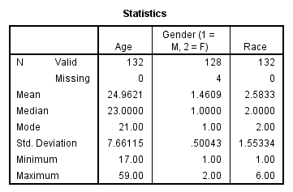

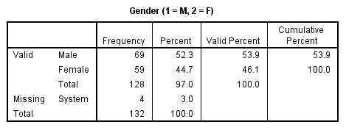

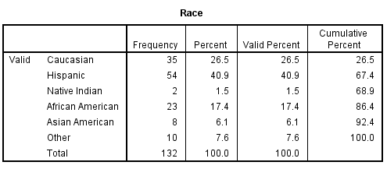

Appendix B – Crosstabs and Chi Square – Study One
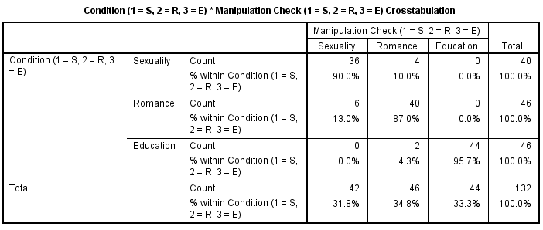
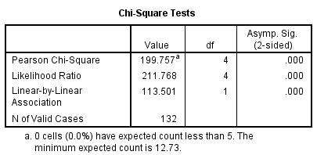

Appendix C – ANOVA Provocative – Study One
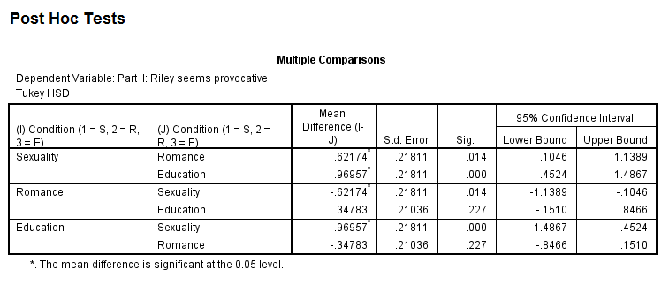
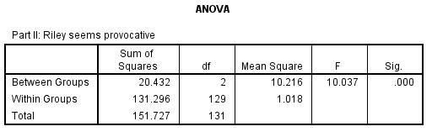
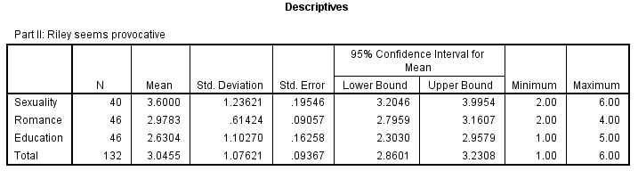

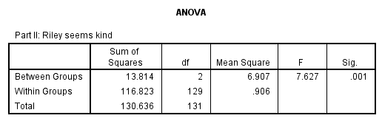
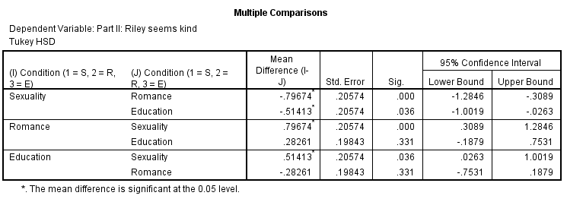
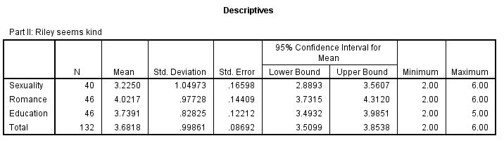
Appendix D - ANOVA Kind – Study One

Appendix E – Demographics – Study Two

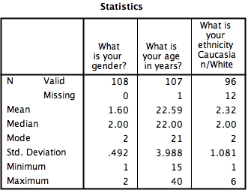

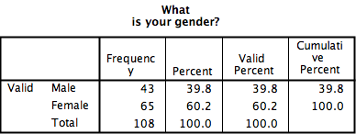

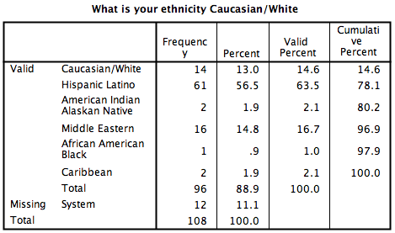

Appendix F - Crosstabs and Chi Square – Study Two

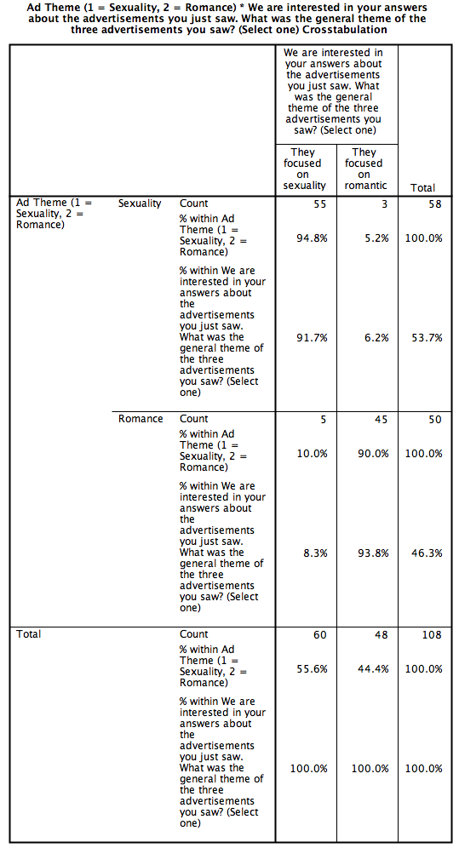
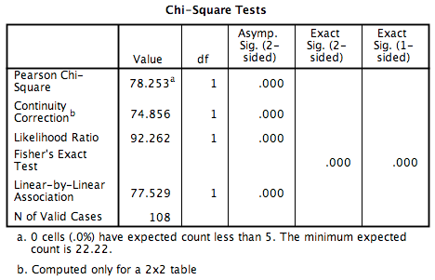
Appendix G – ANOVA Riley Seems Provocative – Study Two 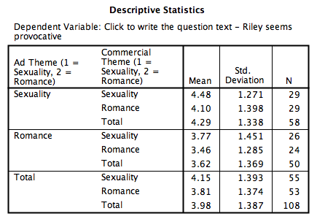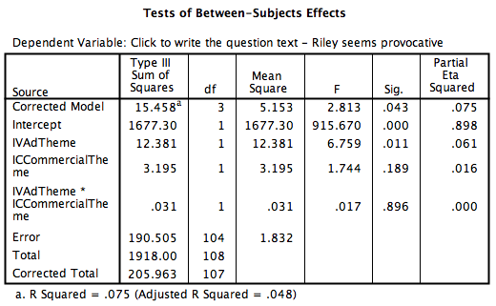

Appendix H – ANOVA Riley Seems Kind – Study Two 